Reactive Forms — FormBuilder, FormGroup, FormArray & Custom Validators
Task 1: Build a Reactive Form with FormBuilder
Goal: Define and bind a reactive form using FormBuilder.
Aim: Create a Student Enrollment Form using Angular Reactive Forms and FormBuilder.
reactive-enrollment-form.ts:
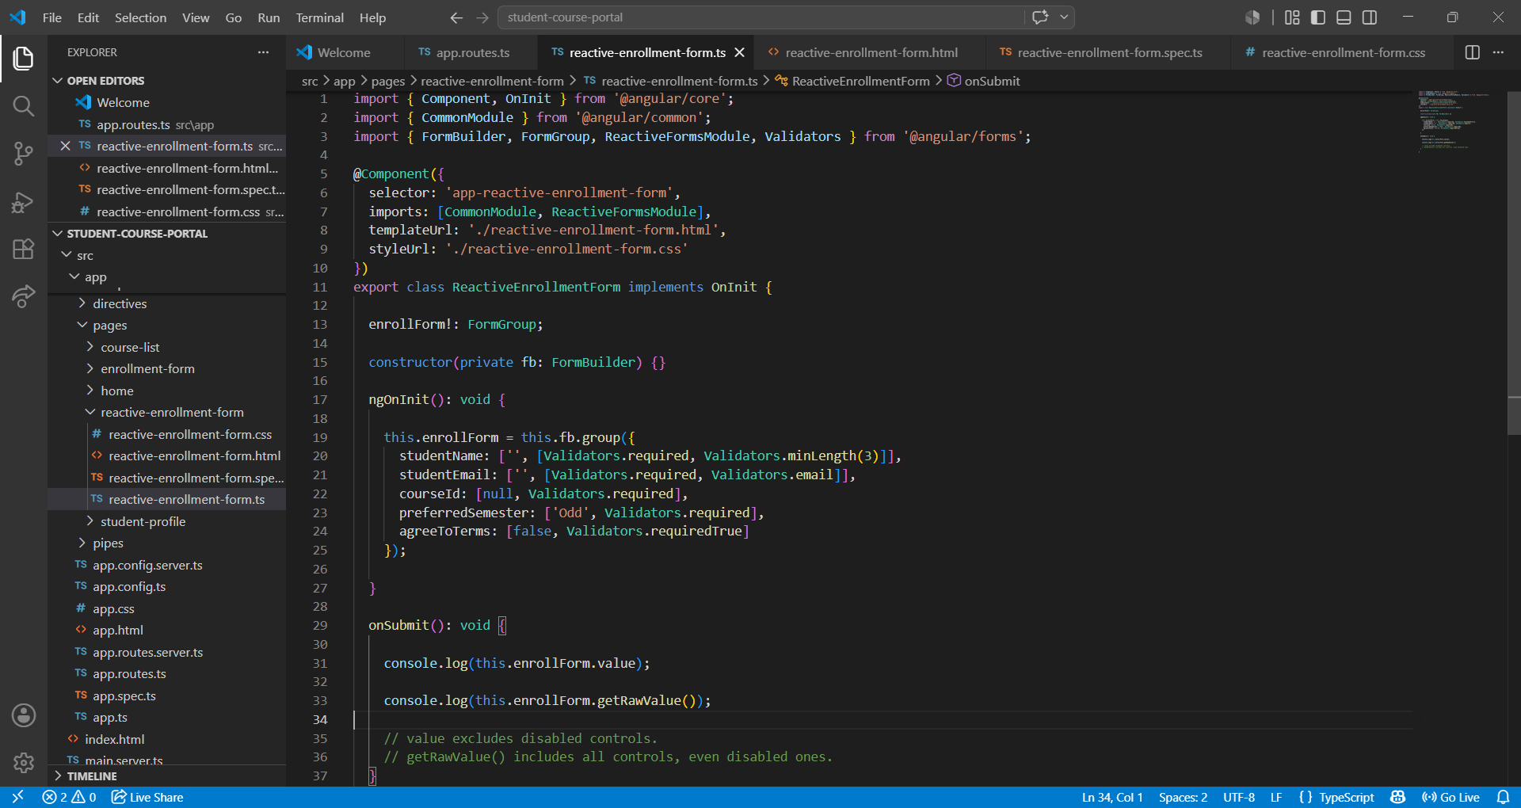

reactive-enrollment-form.html:
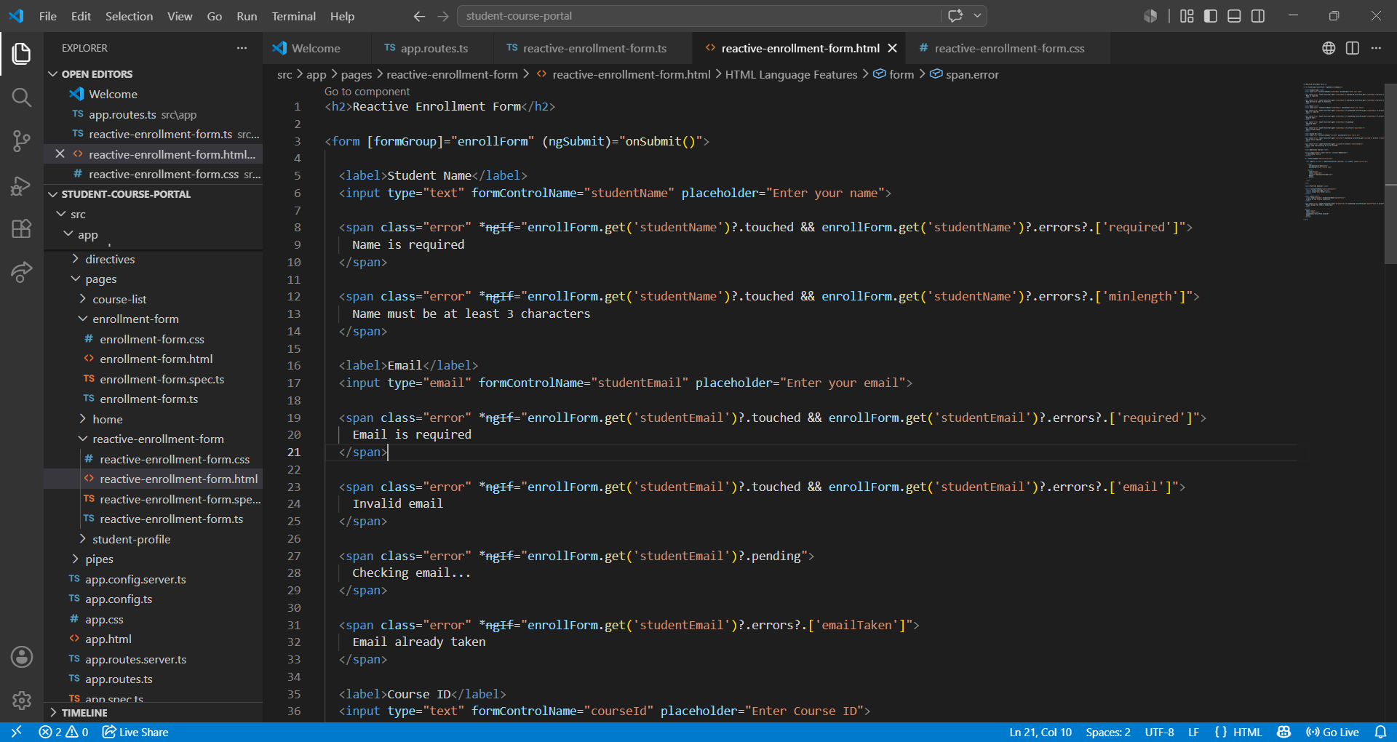

Output:
The Submit Enrollment button doesn’t when any of the field doesn’t matches the
requirement
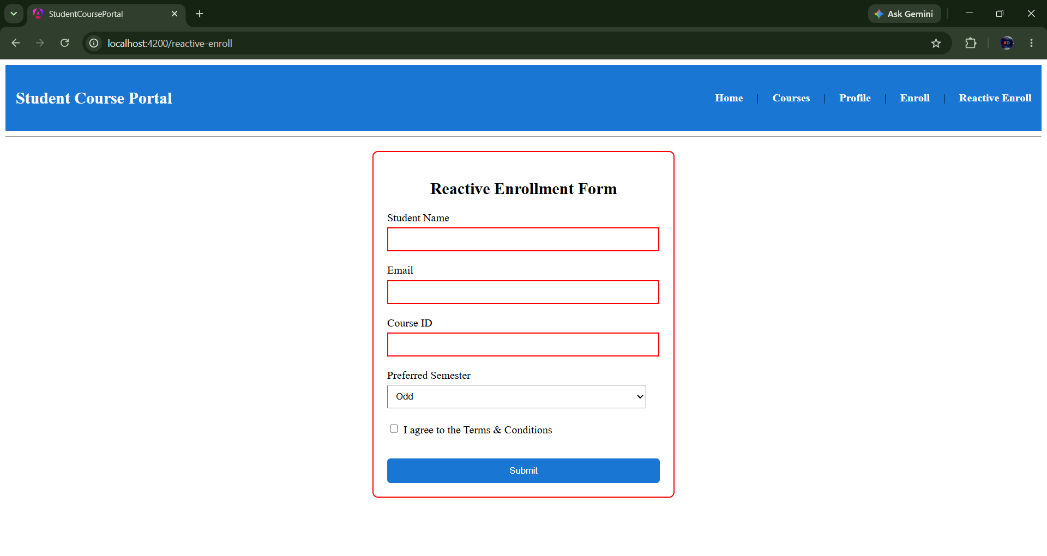

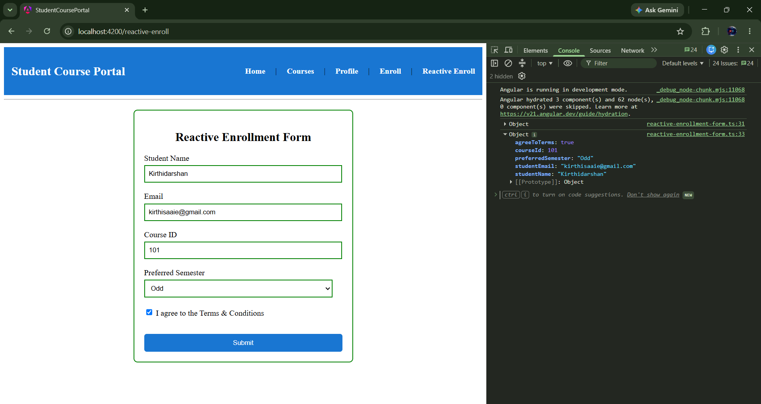

Task 2: Custom Validators and FormArray for Dynamic Controls
Goal: Write a custom synchronous validator and use FormArray for repeating controls.
Aim:To implement a custom synchronous validator, an asynchronous validator, and a dynamic FormArray in Angular Reactive Forms for advanced form validation and dynamic input handling.
Added noCoursecode
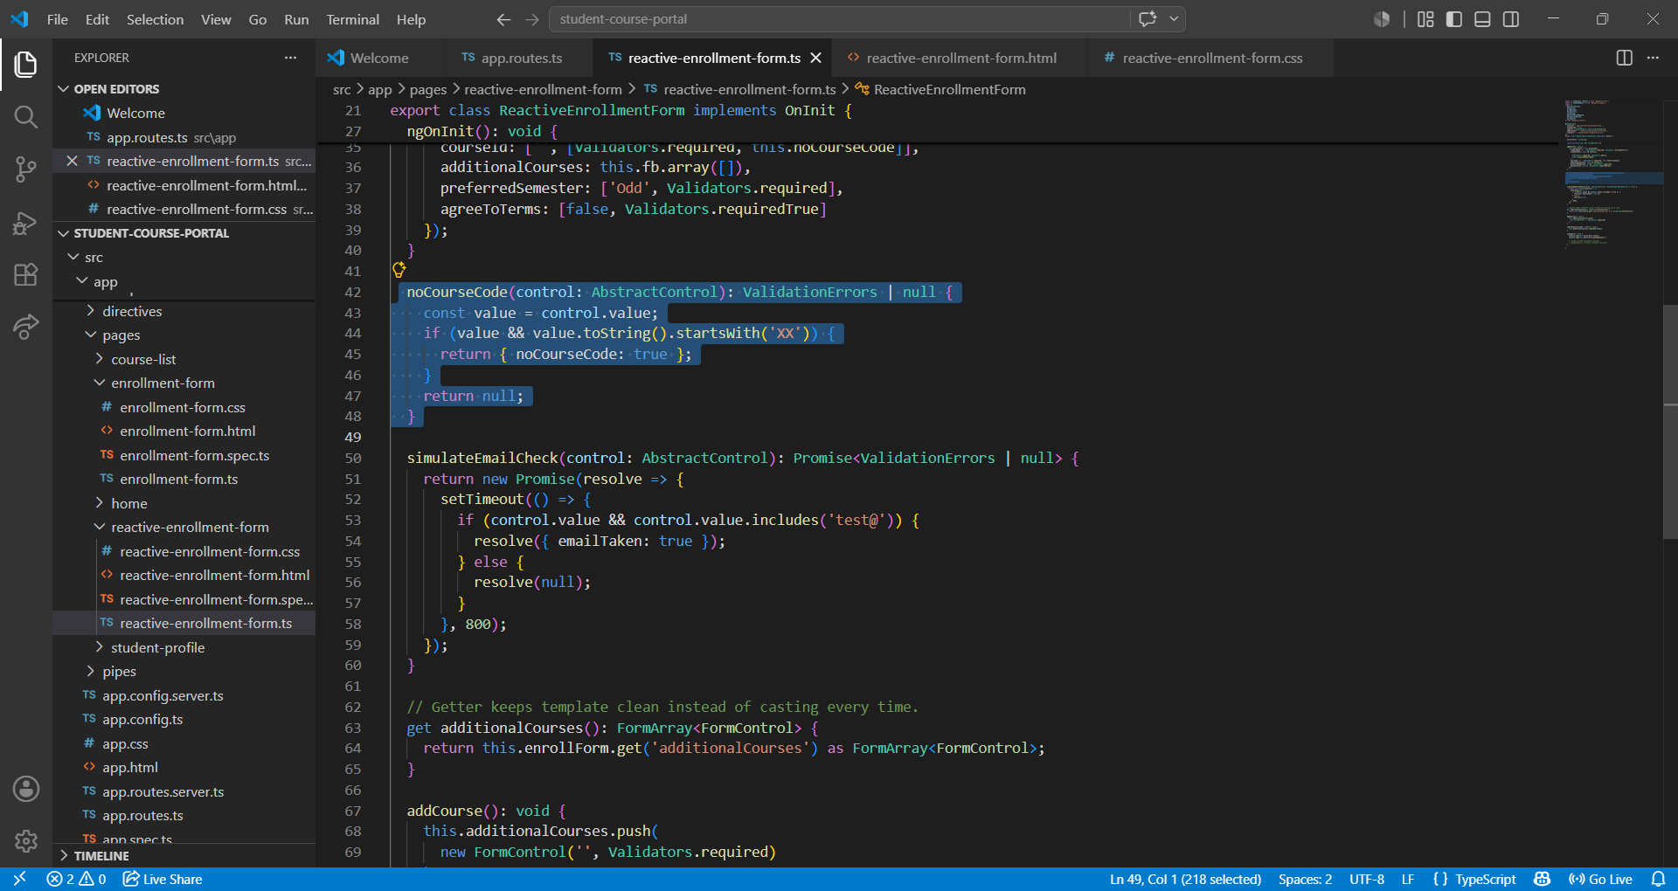

Added simulateEmailCheck
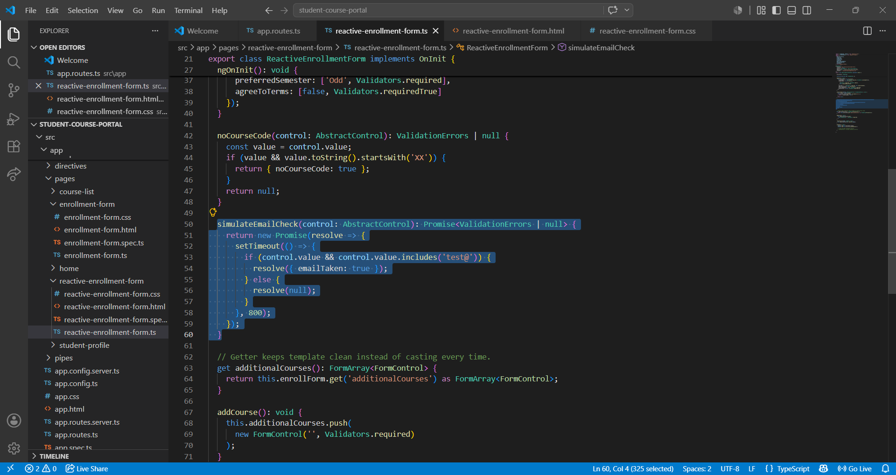

Adding new section Additional Course
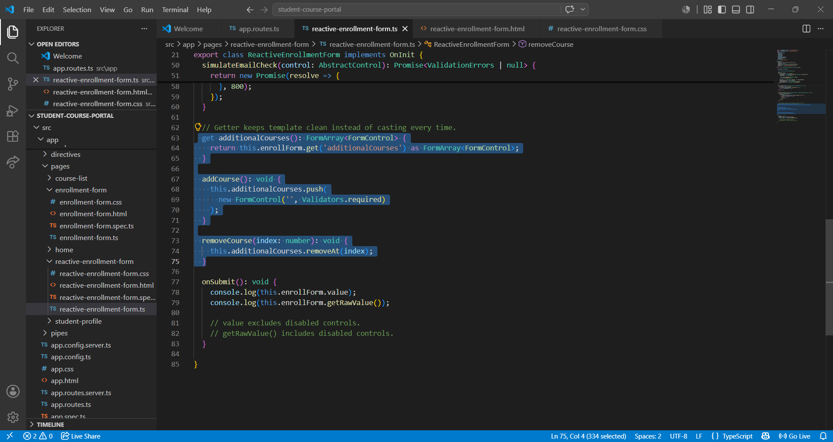

Output:
Invalid Course Id Starting with “XX”
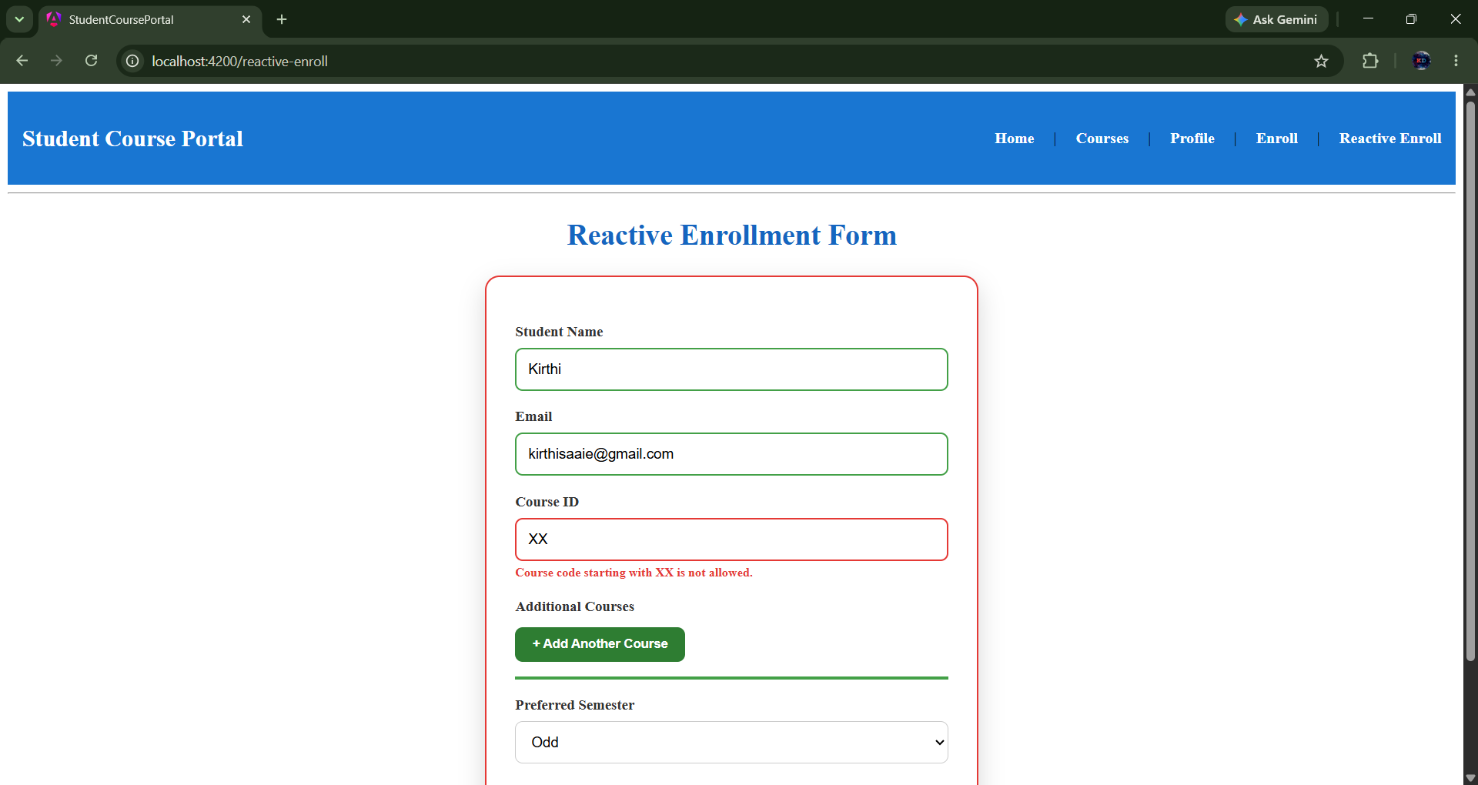

Simulation of error for registering with existing Email
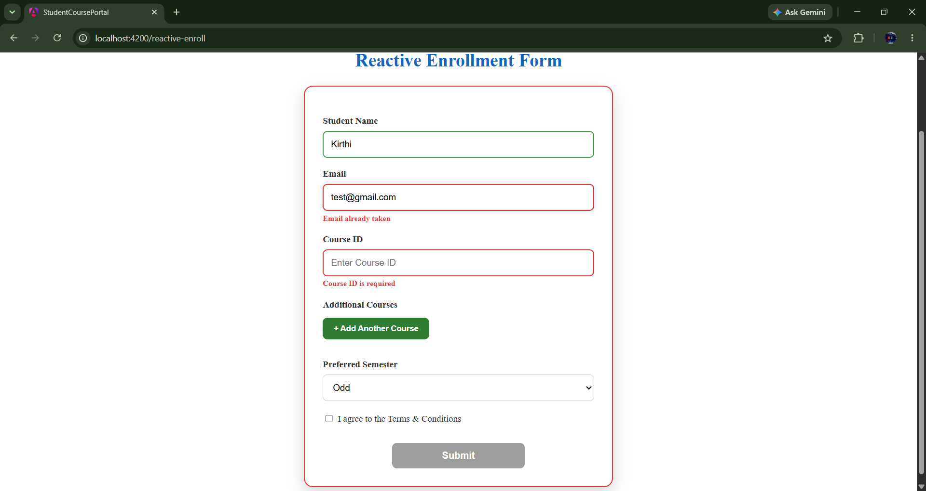

Adding Additional Course to the Enrollment
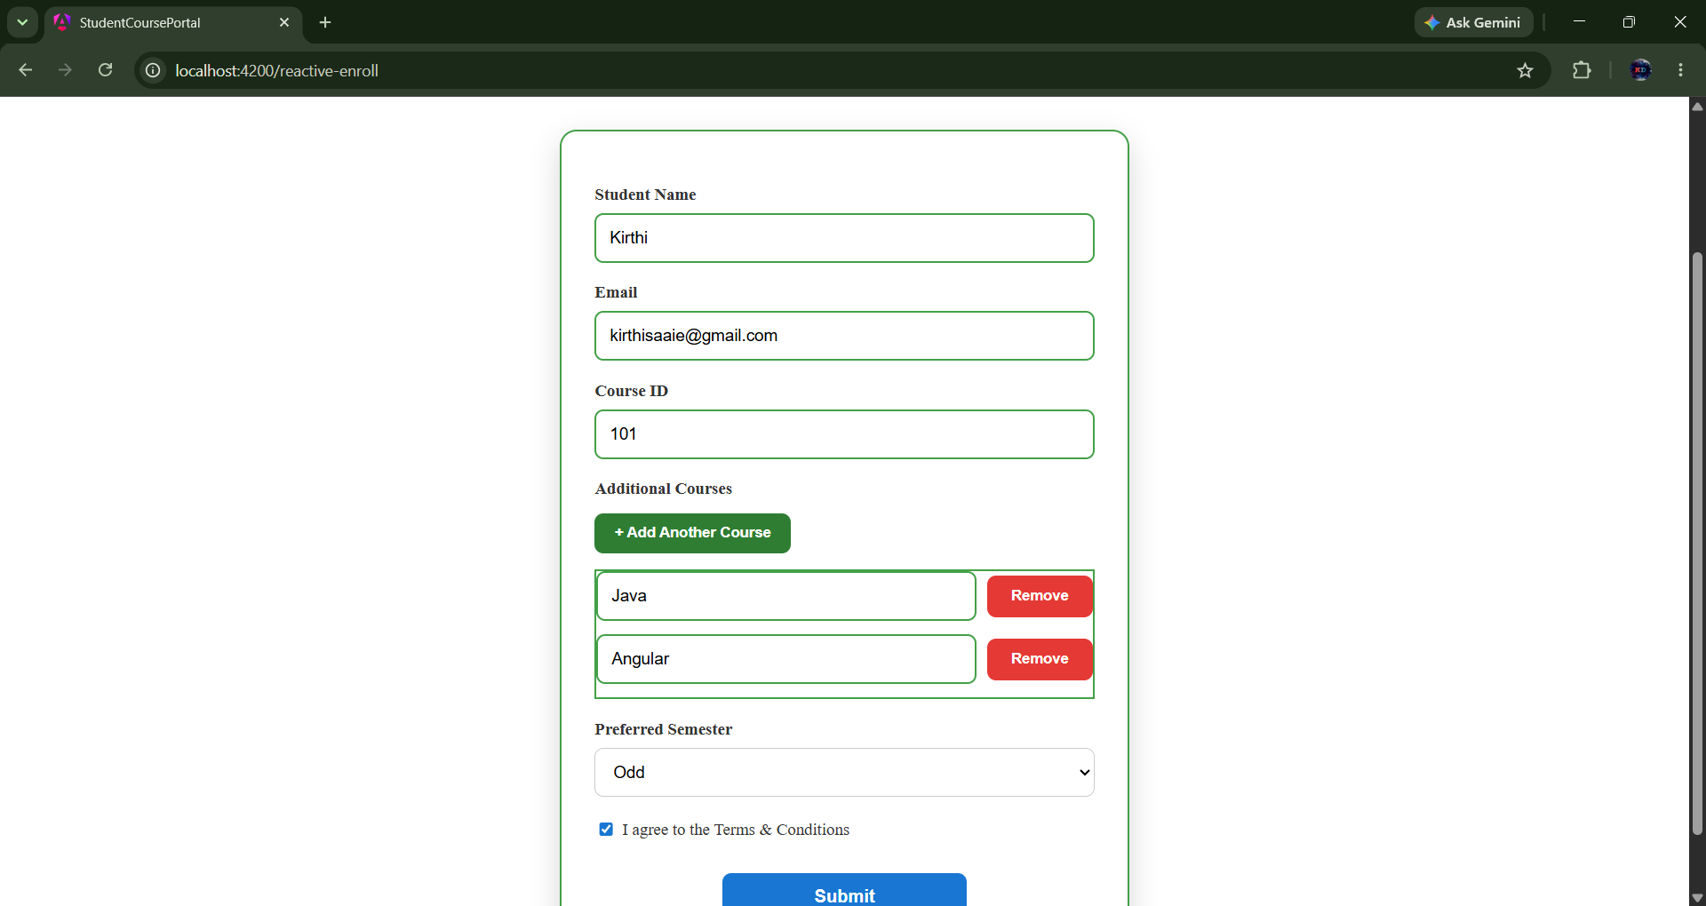

Courses can be added and removed Dynamically
